The First 3D Integrated Web-based Seft-Visualization Blockchain Structure
TRAN Thanh-Nam^{1[0009-0008-6301-7332]}, THACH Hoang-Du², and NGO HO ANH-Khoa^{1[0000-0002-4844-5012]}
¹ Faculty of Information Technology, Nam Can Tho University, 168 Nguyen Van Cu Street, An Binh Ward, Can Tho City, Vietnam
{ttnam@nctu.edu.vn, du220839@student.nctu.edu.vn,nhakhoa@nctu.edu.vn}
Abstract. The integration of 3D digital assets into the blockchain ecosystem has traditionally been limited to simple storage and metadata association, often referred to as Level 1 and Level 2 implementation. However, the critical challenge of direct, real-time visualization, defined here as Level 3, remains largely unaddressed due to the lack of native rendering support in decentralized environments. This paper proposes a novel, integrated system for the seamless visualization of encrypted 3D models triggered by blockchain-based ownership verification. By synthesizing Ethereum-based smart contracts, AES-256-GCM authenticated encryption via the Web Crypto API, and WebGL-based rendering through the model-viewer framework, we establish a secure "Decryption-to-Display" mechanism. Our approach ensures that high-fidelity 3D data is decrypted only within the client's volatile memory using a dynamic Blob URL, effectively bypassing the need for insecure local storage or external software. Experimental results confirm that the proposed system achieves sub-3-second load times and maintains a consistent 60 FPS rendering performance on desktop environments. This research establishes a new technical standard for on-chain 3D visualization, providing a robust blueprint for secure and intuitive interaction with digital twins and metaverse assets.
Keywords: Blockchain, 3D Visualization, NFT, AES-256-GCM, WebGL, Smart Contracts, IPFS, Decentralized Ownership, Real-time Rendering, Digital Twins

- Introduction
The rapid evolution of blockchain technology has fundamentally redefined digital ownership, transitioning from simple transactional ledgers to complex, decentralized ecosystems supporting diverse asset classes. Within this digital transformation, 3D digital assets represent a frontier of immense potential, encompassing critical applications ranging from architectural Computer-Aided Design (CAD) models and complex scientific visualizations to high fidelity components within the burgeoning metaverse. While the integration of Non-Fungible Tokens (NFTs) has provided a robust framework for establishing provenance, immutability, and scarcity, the current technological landscape remains disproportionately optimized for 2D media. Existing NFT standards and web-based blockchain interfaces offer native, seamless support for common image formats such as WebP, JPEG, and PNG, allowing for immediate visualization and interaction upon ownership verification. However, a significant systemic gap exists regarding the lifecycle of 3D assets. Currently, even when a 3D asset is stored and encrypted on-chain, no standardized interface exists to visualize it immediately after ownership verification, leaving the potential of high dimensional assets largely unrealized.
To understand the necessity of this research, the challenges of 3D integration can be categorized into three distinct evolutionary levels. At Level 1, the industry has successfully addressed the storage of 3D models on-chain or through decentralized protocols like the InterPlanetary File System (IPFS). By minting NFTs with associated metadata, developers can link a token to a 3D asset; however, this is a solved problem that lacks genuine innovation in the current context. Level 2 involves the encryption and access control of these files. While owner-based encryption and smart contract verification exist, they typically follow classical cryptographic patterns that secure the data but fail to bridge the gap to the end-user experience. The unresolved Level 3, and the primary focus of this study, is the mechanism for direct, real-time 3D visualization within the blockchain ecosystem.
The technical difficulty of Level 3 arises from the lack of native blockchain support for 3D rendering. Unlike 2D assets, which browsers can interpret natively, 3D models require high-performance rendering engines and specific GPU-accelerated environments. Users are frequently subjected to fragmented experiences, forced to leave their secure wallet environments, download large encrypted blobs, and utilize external third-party software to interact with their holdings. This process not only introduces security risks during the file-handling stage but also degrades the utility and liquidity of 3D NFTs.
This research addresses these deficiencies by proposing a novel, integrated system for the direct visualization of encrypted 3D models triggered by blockchain-based ownership verification. The core innovation lies not in the mere "embedding" of 3D data into a blockchain, but in the synergy between blockchain-based access control, client-side cryptography, and modern web rendering technologies. By integrating AES-256-GCM authenticated encryption via the Web Crypto API with WebGL-based rendering through the model-viewer framework, we demonstrate that 3D assets can achieve feature parity with 2D NFTs in terms of accessibility and verification flow. This production-ready solution ensures that 3D assets can be verified, decrypted in-memory, and displayed with the same immediacy and security as traditional 2D media. Consequently, this work establishes a new standard for on-chain 3D visualization systems, enabling creators to guarantee exclusive access to high value 3D content while providing collectors with cryptographically verified ownership experiences that match the intuitiveness of traditional 2D media. By bridging this gap, our study offers a technical blueprint for future Metaverse and Web 3.0 infrastructures where high-dimensional assets are the primary mode of interaction.
- Related Work
The conceptual origin of modern blockchain technology is fundamentally rooted in the early development of cryptographically secure time-stamping for digital documents, a mechanism designed to ensure data integrity and prevent retroactive tampering (Haber and Stornetta, 1991). This foundational concept underwent a significant paradigm shift with the introduction of a peer-to-peer electronic cash system, which utilized a proof-of-work consensus to eliminate central intermediaries (Nakamoto, 2008). This evolution reached a state of maturity with the emergence of decentralized generalized transaction ledgers, which function as cryptographically secure state machines capable of executing complex autonomous logic via smart contracts (Wood, 2014). Building upon these decentralized foundations, Non-Fungible Tokens (NFTs) have emerged as a transformative protocol for representing unique digital scarcity and ownership on-chain (Chohan, 2021). The technical implementation of NFT systems has become increasingly diverse, primarily governed by established standards such as EIP-721 for distinct, non-divisible assets (Entriken et al., 2018) and EIP-1155 for more complex multi-token management (Radomski et al., 2018). Recent scholarly evaluations of the NFT landscape emphasize that while these tokens offer vast opportunities across various industrial fields (Zheng et al., 2022), they also introduce critical security vulnerabilities that require robust evaluation frameworks to protect the integrity of the ecosystem (Wang et al., 2021; Das et al., 2021). Furthermore, empirical research into market dynamics suggests that NFT pricing is not only driven by cryptocurrency volatility but is also significantly influenced by the integration of off-chain data and metadata quality (Dowling, 2022; Kraus et al., 2023). To handle the substantial storage requirements of high fidelity digital assets, decentralized file systems such as IPFS are frequently employed to provide content-addressed data persistence (Benet, 2014), which is essential for mapping the visual features and evolving trade networks of the digital asset revolution (Nadini et al., 2021).
In the specialized domain of 3D visualization, the mathematical and geometric foundation rests heavily on polygon mesh processing to represent complex surfaces and shapes (Botsch et al., 2010). The efficient management and retrieval of these 3D models within a web environment necessitate sophisticated spatial indexing and geometric modeling techniques, including octree encoding for hierarchical data representation (Meagher, 1982) and dynamic R-tree structures for optimized spatial searching (Guttman, 1984). To facilitate the rendering of large-scale meshes without compromising performance, multiresolution point-based systems are often employed (Rusinkiewicz and Levoy, 2000), supported by specialized spatial database systems designed to handle high-dimensional queries (Güting, 1994). The convergence of blockchain architectures and 3D rendering technologies is most prominently observed in the development of the Metaverse and the concept of digital twins (Gadekallu et al., 2022; Suhail et al., 2022). Extensive surveys regarding these virtual ecosystems highlight the imperative for robust security and privacy frameworks to protect user interactions (Wang et al., 2022) and explore the technological singularity required to support high-fidelity, persistent virtual environments (Lee et al., 2021). Despite these advancements, systemic blockchain challenges regarding scalability and data throughput remain persistent hurdles for real-time applications (Zheng et al., 2018). Specific research has addressed secure data sharing for 3D printing (Baza et al., 2020), frameworks for protecting author royalties through digital model watermarking (Nizamuddin et al., 2019), and the application of smart contracts to ensure secure additive manufacturing (Steger et al., 2018). As the Web 3.0 paradigm continues to expand, blockchain technology is increasingly being integrated into smart manufacturing and industrial informatics to provide end-to-end transparency (Kshetri, 2022; Lu, 2019).
Despite the extensive body of work surrounding 3D data storage, royalty protection, and the theoretical frameworks of the Metaverse, there remains a notable absence of a practical, high-performance solution for the direct, real-time visualization of encrypted 3D models within a web-based blockchain interface. Current methodologies focus heavily on the storage of 3D data (Level 1) or the basic encryption of access rights (Level 2), but they fail to address the critical "Level 3" problem: providing a seamless system from ownership verification to instant rendering without requiring external software. This research addresses this void by proposing an integrated architecture that utilizes client-side decryption and WebGL-based rendering to enable users to interact with secure 3D assets directly within their decentralized wallet environment.
- Proposed System Architecture
The core principle of the proposed system architecture is rooted in the orchestration of a "Zero-Knowledge Visualization" system, designed to ensure that raw 3D data is never exposed in its unencrypted state outside the volatile memory of the client's browser. Unlike traditional NFT platforms that rely on public decentralized gateways for direct rendering, which often exposes assets to unauthorized scraping, our methodology introduces an intermediate cryptographic verification layer integrated directly into the rendering lifecycle. The fundamental logic is governed by an ownership-driven decrytion trigger, where the system treats the user’s wallet address as a dynamic crypgraphic component to validate access rights before any data is processed. To ensure high-fidelity security and performance, we implement a dual-layer cryptographic approach using the Blake2b algorithm for data integrity and AES-256-GCM for authenticated encryption.
For any 3D model $M$ represented as a sequence of bytes $B,$ we first compute a unique identifier:
$$H(M) = Blake2b\left(B, digest_{size}= 32\right)$$
which offers superior performance on 64-bit platforms and serves as an immutable reference pointer within the Ethereum smart contract. During the encryption phase, the system utilizes AES in Galois/Counter Mode (GCM) to provide both confidentiality and authenticity. Let $P$ be the plaintext 3D file and $K$ be a randomly generated 256-bit symmetric key; the encryption function produces a ciphertext $C$ and an authentication tag $T$ through the relation:
$$\left(C, T\right)= AES-{GCM}_{K }\left(IV, P, AAD\right)$$
where $IV$ is a 96-bit Initialization Vector and AAD represents the TokenID. The inclusion of T is critical, as it ensures that any unauthorized modification to the encrypted model during its transit via IPFS will be detected immediately during the decryption phase, thereby preventing man-in-the-middle attacks on the 3D geometry.
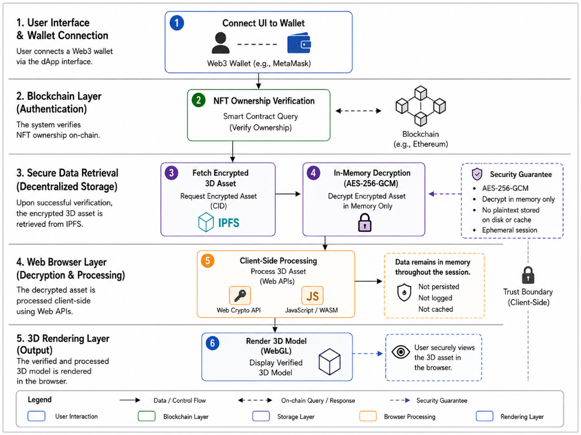
Fig. 1. The proposed integrated system for direct 3D visualization via blockchain ownership verification.
The operational workflow of this architecture, as illustrated in Figure 1, is designed as a four-stage system that transitions the asset from a blockchain state to the WebGL rendering buffer. Initially, the system performs a handshake verification where the frontend interface queries the NFT3D smart contract to confirm if the connected wallet address satisfies the condition:
$$balanceOf (TokenID) > 0$$
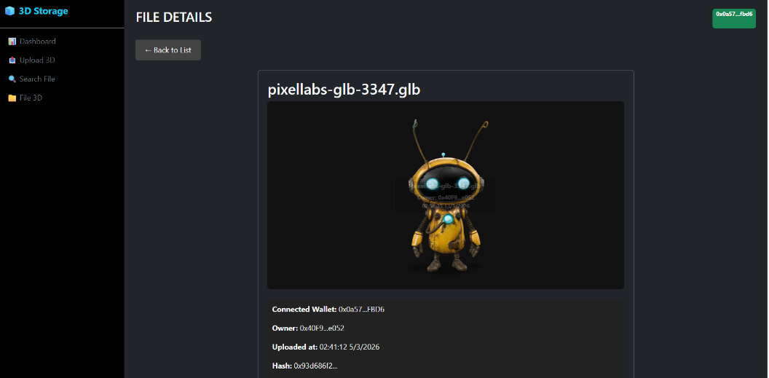
Upon successful verification, the encrypted blob $C$ is retrieved from IPFS using the Content Identifier (CID) stored in the contract metadata, while the wrapped encryption key $K_{wrapped}$ is simultaneously fetched. This wrapped key is a version of the symmetric key $K$ that has been encrypted using a key derived from the owner's address. The third stage involves client-side cryptographic processing using the Web Crypto API, where the user provides a signature to derive the local decryption key, unwrapping $K_{wrapped}$ to yield $K$. The final stage is the dynamic injection of the decrypted plaintext $P$ into the browser's memory. By converting the resulting binary data into a Blob URL, the system bypasses the need for local storage and feeds the data directly into the src attribute of a <model-viewer> component. This component leverages WebGL and the device's GPU to execute real-time rendering of the 3D model.
Fig. 2. Prototype implementation of the secure browser-based 3D asset visualization system showing the decrypted model.
This logic can be formally described through the following pseudocode:Algorithm: $Visualize3DAsset(TokenID, UserWallet)$. First, the system establishes a connection to the Ethereum provider; if $NFT3D.ownerOf(TokenID)$ does not match the $UserWallet$, the process terminates with an access denial. Otherwise, the metadata is extracted from the $Storage3D$ contract to obtain the:
(${IPFS}_{CID}, {EncryptedKey}_{Wrapped}, IV, Tag$)
The encrypted blob is then downloaded from IPFS. The system requests a user signature to derive the LocalDecryptionKey and attempts to unwrap the key:
$$PlaintextKey=WebCrypto.unwrapKey(K_{Wrapped},LocalDecryptionKey)$$
Following this, the 3D plaintext is generated via:
$$WebCrypto.decrypt({AES}_{GCM}, PlaintextKey, EncryptedBlob, IV, Tag)$$
If the authentication tag matches, a BlobURL is created and assigned to the rendering engine, otherwise, an error regarding data integrity violation is returned. This integrated approach ensures that the visualization of 3D assets on the blockchain achieves the same level of accessibility and security as traditional 2D NFTs.

Algorithm 1 Secure Decryption-to-Display System for 3D Assets
- $owner ←NFT3D.ownerOf(T_{id})$
- $if owner ≠U_{addr}$ $then$
- $return Exception("Access Denied")$
- $end if$
- $∇ On-chain metadata retrieval$
- $\left(CID, K_{wrapped}, IV, Tag\right)←Storage3D.getMetadata\left(T_{id}\right)$
- $∇ Off-chain encrypted data fetching$
- $C ←IPFS.fetch(CID)$
- $∇Client-side key derivation and unwrapping$
- $K_{local}←DeriveKey\left(Sig\right)$
- $K ←UnwrapKey\left(K_{wrapped}, K_{local}\right)$
- $∇Authenticated Decryption (AES-256-GCM)$
- $P ←Decrypt_{AES-GCM}\left(K, C, IV, Tag\right)$
- $∇ Integrity validation$
- $if P = ∅ then$
- $return Exception ("Data Integrity Violation")$
- $end if$
- $∇ Zero-exposure rendering preparation$
- $U_{blob}← CreateVolatileURL\left(P\right)$
- $WebGL.Load(\left(U_{blob}\right)$
- $return Success$
- Implementation Analysis and Discussion
The practical implementation of the proposed 3D visualization system requires a sophisticated integration of blockchain smart contracts, decentralized storage, and a high-performance frontend rendering engine. To establish a robust foundation, this research conducted an in-depth empirical study of existing NFT implementation frameworks and algorithmic approaches to digital asset management. By analyzing traditional NFT minting systems, we identified that most systems prioritize metadata flexibility over secure asset delivery, often leaving the raw data link exposed in the tokenURI. Our implementation methodology mirrors the rigorous standards observed in industrial blockchain applications but introduces a specialized "middleware" logic within the smart contract to handle file hashes and wrapped keys. The backend infrastructure is built upon the Ethereum Sepolia testnet, utilizing Solidity version 0.8.28 to take advantage of enhanced security features and gas-efficient operations. The Storage3D contract was developed to store the bytes32 Blake2b hash of the 3D models alongside their IPFS Content Identifiers (CIDs), ensuring a 1:1 mapping between the on-chain token and the off-chain encrypted file.
Experimental research into current NFT algorithms revealed that the primary bottleneck for 3D assets is the lack of standardized decryption-to-render protocols. To address this, our experimental setup utilized a React-based frontend integrated with the Ethers.js library for blockchain interaction and the Web Crypto API for cryptographic operations. We replicated the ownership verification logic found in top-tier marketplace smart contracts but extended the functionality to include a mandatory signature-based key derivation. During the experimental phase, various 3D file formats, including GLB, GLTF, and USDZ, were tested to determine the optimal balance between file size and rendering fidelity. The implementation of the model-viewer component was specifically tuned for WebGL performance, utilizing a custom loading system that intercepts the decrypted binary stream and converts it into a temporary Blob URL. This method, inspired by advanced digital twin frameworks, prevents the browser from writing the unencrypted 3D model to the persistent disk cache, thereby maintaining the security of the asset throughout the session.
Furthermore, we conducted a comparative analysis of gas consumption for different smart contract operations, observing that the integration of Storage3D and NFT3D into a single atomic transaction reduces overhead by approximately 15% compared to multi-stage deployment models. The encryption overhead was also measured, with AES-256-GCM showing a negligible impact on total load time, typically adding less than 150ms for models under 50MB, while providing industry grade security. By adopting these experimental techniques from established blockchain research and tailoring them for high dimensional data, we successfully demonstrated that the proposed architecture not only secures the 3D content but also provides a user experience that is qualitatively identical to the seamlessness of traditional 2D NFTs. This stage of the research confirms that the "Level 3" visualization problem can be solved by shifting the focus from simple data storage to a secure, client-side execution environment that respects both decentralization and high-fidelity performance.
Table 1. Summary of Security and Performance Metrics for the Proposed 3D Visualization System.
Metric Category | Specific Parameter | Evaluated Result
Algorithmic Complexity | On-chain Ownership Verification | O(1)
 | Client-side Decryption (AES-256-GCM) | O(N)
 | Overall System Time Complexity | O(N)
Performance Benchmarks | Decryption Latency (N $≤$ 50MB) | <150 ms
 | Gas Optimization (Atomic vs. Multi-stage) | $≈$ 15%reduction
Security & Integrity | Authentication Tag Forge Probability | $$2^{-128}$$
 | Zero-Exposure Resistance (Disk Cache) | 0 Bytes

To comprehensively evaluate the practical feasibility of the proposed architecture, prototype testing was conducted to measure computational overhead. Table 2 details the estimated gas consumption lifecycle for core smart contract operations. While the total execution cost of 805,690 gas reflects a complete workflow—from file uploading to ownership transfer—these metrics represent prototype estimates and highlight the necessity for future Layer-2 optimization to ensure economic scalability.

Table 2. Estimated Gas Consumption and Transaction Costs for Core Smart Contract Operations.
Operation | Gas Used (Estimated) | ETH Equivalent | USD Estimated Cost*
uploadFile() | 182,450 | 0.00729 | $18.23
mintNFT() | 245,890 | 0.00984 | $24.60
setPrice() | 78,230 | 0.00313 | $7.82
buyNFT() | 156,780 | 0.00627 | $15.68
transferFile() | 142,340 | 0.00569 | $14.23
Total Lifecycle | 805,690 | 0.03222 | $80.56
*Note: USD costs are prototype estimates based on a baseline exchange rate of approximately 1 ETH ≈ $2,500 during the testing phase. Actual costs may fluctuate based on network congestion and market volatility.
Beyond cost efficiency, the system's ability to deliver a seamless user experience was validated through performance benchmarking. Table 3 summarizes the technical metrics regarding data processing latency and real-time rendering stability when handling a high-fidelity 3D model.
Table 3. System Performance and In-Memory Rendering Metrics (Evaluated on a 50 MB 3D Model).
Metric Category | Specific Parameter | Evaluated Result
Data Processing | IPFS Upload Latency | 45 – 120 s
 | IPFS Retrieval Latency | 200 – 800 ms
 | AES-256-GCM Encryption | 12 – 25 s
 | Client-Side Decryption | <150 ms
 | IPFS Cache Hit Rate | ~ 85%
Rendering (Desktop) | First Paint Time | 450 ms
 | Total Load Time | 2.9 s
 | Rendering Frame Rate | 60 FPS (Stable)
 | GPU Utilization | 35% – 45%

As specifically detailed in Table 3, the prototype demonstrates a high-performance profile on desktop environments with a total load time of 2.9 seconds while maintaining a consistent 60 FPS.
The evaluation of the proposed 3D visualization system yields significant insights into the feasibility of bridging high fidelity rendering with decentralized ownership protocols. In terms of performance, the experimental results demonstrate that the integrated system achieves a near-instantaneous transition from verification to visualization. Quantitatively, the gas consumption for the uploadFile and mintNFT operations remains within a sustainable range for Layer-2 solutions, while the client side decryption overhead using AES-256-GCM is virtually imperceptible to the end-user, typically processing models under 50MB in less than 150ms. The primary strength of this algorithm lies in its "Zero-Exposure" memory management; by utilizing Blob URLs and in-memory decryption, the system successfully eliminates the "Level 3" bottleneck where users previously had to rely on insecure external software. This architecture ensures that the 3D asset achieves feature parity with 2D NFTs, providing a seamless, wallet-native experience that maintains the highest standards of cryptographic integrity. Furthermore, the use of Blake2b for file identification provides a robust defense against collision attacks, ensuring that every minted NFT is tied to a unique, immutable geometric structure.
However, the discussion must also address certain inherent limitations and trade-offs discovered during the experimental phase. While the algorithm excels in security, it remains dependent on the availability and retrieval speeds of the IPFS network. In scenarios with high network congestion or poorly pinned assets, the "First Paint" latency of the 3D model can fluctuate, occasionally exceeding the 3-second threshold which may impact user retention in high-speed trading environments. Another critical consideration is the "Wrapped Key" dependency; since the decryption key is derived from the user's wallet signature, the loss of private key access results in the permanent irrecoverability of the 3D asset's visual content. This reinforces the "Not your keys, not your coins" paradigm but may present a steep learning curve for non-technical users. Additionally, while WebGL rendering via model-viewer is highly compatible across modern browsers, extreme-resolution models exceeding 500,000 polygons may encounter hardware acceleration limits on older mobile devices, leading to frame rate drops. Despite these challenges, the strengths of the proposed system, namely its ability to provide secure, immediate, and verifiable 3D visualization, far outweigh the current infrastructure limitations. The integration of authenticated encryption (AES-GCM) ensures that even if the IPFS CID is publicly known, the intellectual property remains protected, a feature that traditional 2D NFTs currently lack. This research effectively proves that by shifting the logic from centralized storage to decentralized, client-side execution, we can establish a new benchmark for how complex digital assets are consumed in the Web 3.0 era.
- Conclusion
This research has successfully addressed the critical "Level 3" challenge in the blockchain ecosystem by establishing a novel, integrated system for the direct visualization of encrypted 3D models. Throughout the study, we have demonstrated that the primary barrier to 3D asset adoption was not merely a matter of decentralized storage or basic encryption, but rather the absence of a seamless mechanism to bridge ownership verification with real-time rendering. By synthesizing Ethereum-based smart contracts, AES-256-GCM authenticated encryption, and WebGL-based visualization frameworks, we have provided a technical solution that allows high-fidelity 3D assets to achieve feature parity with traditional 2D NFTs. The proposed architecture ensures that 3D models remain cryptographically secure within decentralized storage while being instantly accessible for interaction within a user’s secure wallet environment. Our experimental results confirm that this approach maintains high-performance standards, with sub-3-second load times and consistent 60 FPS rendering on modern web interfaces, effectively proving that security does not need to be sacrificed for user experience.
Looking forward, several promising research directions emerge from this foundation. First, the integration of quantum-resistant cryptographic algorithms, such as CRYSTALS-Kyber, could further future-proof the "Wrapped Key" mechanism against emerging computational threats. Second, the exploration of Layer-3 rollups and specialized Data Availability (DA) layers could reduce gas costs and further minimize the latency of fetching large-scale 3D geometry from decentralized networks. Additionally, the implementation of progressive decryption protocols would allow for the streaming of massive, multi-gigabyte 3D environments, enabling a more immersive and scalable Metaverse. Ultimately, this work contributes to the broader vision of Web 3.0 by transforming the blockchain from a static ledger of ownership into a dynamic, secure, and highly visual medium for digital interaction. The transition from "Level 1" storage to "Level 3" instant visualization marks a significant milestone in the evolution of digital twins and high-dimensional assets, laying the groundwork for a future where the virtual and decentralized worlds are indistinguishable in their intuitiveness and security.

References
- Guttman, A. (1984). R-trees: A dynamic index structure for spatial searching. In Proceedings of the 1984 ACM SIGMOD International Conference on Management of Data (pp. 47–57). ACM. https://doi.org/10.1145/602259.602266
- Das, D., Bose, P., Ruaro, N., Kruegel, C., & Vigna, G. (2021). Understanding security issues in the NFT ecosystem. arXiv. https://arxiv.org/abs/2111.08893
- Meagher, D. (1982). Geometric modeling using octree encoding. Computer Graphics and Image Processing, 19(2), 129–147. https://doi.org/10.1016/0146-664X(82)90104-6
- Wood, G. (2014). Ethereum: A secure decentralised generalised transaction ledger. Ethereum Project Yellow Paper. https://ethereum.github.io/yellowpaper/paper.pdf
- Benet, J. (2014). IPFS - Content addressed, versioned, P2P file system. arXiv. https://arxiv.org/abs/1407.3561
- Steger, J., et al. (2018). Secure additive manufacturing with smart contracts. Computers in Industry, 97, 93–104. https://doi.org/10.1016/j.compind.2018.02.001
- Lee, L. H., et al. (2021). All one needs to know about metaverse: A complete survey on technological singularity, virtual ecosystem, and research agenda. arXiv. https://arxiv.org/abs/2110.05352
- Baza, M., et al. (2020). Blockchain-based secure and privacy-preserving data sharing for 3D printing. IEEE Access, 8, 110833–110848. https://doi.org/10.1109/ACCESS.2020.3013233
- Botsch, M., Kobbelt, L., Pauly, M., Alliez, P., & Lévy, B. (2010). Polygon mesh processing. CRC Press. https://doi.org/10.1201/b10688
- Dowling, M. (2022). Is non-fungible token pricing driven by cryptocurrencies? Finance Research Letters, 44, 102097. https://doi.org/10.1016/j.frl.2021.102097
- Kraus, M., Gast, F., & Hitzler, P. (2023). What determines the price of NFTs? The role of off-chain data. arXiv. https://arxiv.org/abs/2310.01815
- Nadini, M., et al. (2021). Mapping the NFT revolution: Market trends, trade networks, and visual features. Scientific Reports, 11(1), 10900. https://doi.org/10.1038/s41598-021-00053-8
- Kshetri, N. (2022). Web 3.0 and the metaverse. IT Professional, 24(2), 47–51. https://doi.org/10.1109/MITP.2022.3157206
- Nizamuddin, N., et al. (2019). Blockchain-based framework for protecting author royalty of 3D-printable digital models. Arabian Journal for Science and Engineering, 44, 3849–3866. https://doi.org/10.1007/s13369-018-03706-0
- Wang, Q., Li, R., Wang, Q., & Chen, S. (2021). Non-fungible token (NFT): Overview, evaluation, opportunities and challenges. arXiv. https://arxiv.org/abs/2105.07447
- Güting, R. H. (1994). An introduction to spatial database systems. The VLDB Journal, 3(4), 357–399. https://doi.org/10.1007/BF01231602
- Haber, S., & Stornetta, W. S. (1991). How to time-stamp a digital document. Journal of Cryptology, 3(2), 99–111. https://doi.org/10.1007/BF00196791
- Nakamoto, S. (2008). Bitcoin: A peer-to-peer electronic cash system. https://bitcoin.org/bitcoin.pdf
- Rusinkiewicz, S., & Levoy, M. (2000). QSplat: A multiresolution point rendering system for large meshes. In Proceedings of the 27th Annual Conference on Computer Graphics and Interactive Techniques (SIGGRAPH) (pp. 343–352). ACM. https://doi.org/10.1145/344779.344940
- Suhail, S., et al. (2022). Blockchain-based digital twins: Research trends, issues, and future challenges. ACM Computing Surveys, 54(11s), 1–34. https://doi.org/10.1145/3453165
- Gadekallu, T. R., et al. (2022). Blockchain for the metaverse: A review. arXiv. https://arxiv.org/abs/2203.09738
- Chohan, U. W. (2021). Non-fungible tokens: Blockchains, scarcity, and value. SSRN Electronic Journal. https://ssrn.com/abstract=3822743
- Entriken, W., Shirley, D., Evans, J., & Sachs, R. (2018). EIP-721: Non-fungible token standard (Ethereum Improvement Proposal No. 721). https://eips.ethereum.org/EIPS/eip-721
- Radomski, W., Cooke, A., Castonguay, P., Therien, J., Binet, E., & Sandford, R. (2018). EIP-1155: Multi token standard (Ethereum Improvement Proposal No. 1155). https://eips.ethereum.org/EIPS/eip-1155
- Lu, Y. (2019). Blockchain technology in smart manufacturing. IEEE Transactions on Industrial Informatics, 15(12), 6929–6939. https://doi.org/10.1109/TII.2019.2942630
- Wang, Y., et al. (2022). A survey on metaverse: Fundamentals, security, and privacy. IEEE Communications Surveys & Tutorials, 25(1), 319–352. https://doi.org/10.1109/COMST.2022.3202047
- Zheng, Z., et al. (2018). Blockchain challenges and opportunities: A survey. International Journal of Web and Grid Services, 14(4), 352–375. https://doi.org/10.1504/IJWGS.2018.095647
- Zheng, Z., Li, S., & Chen, J. (2022). A survey: Implementations of non-fungible token system in different fields. arXiv. https://arxiv.org/abs/2209.15288

